CHRYSALIS CHARTER SCHOOL
Home School Attendance Record Sheet
2013-2014

Student’s name __________________________________________________________________

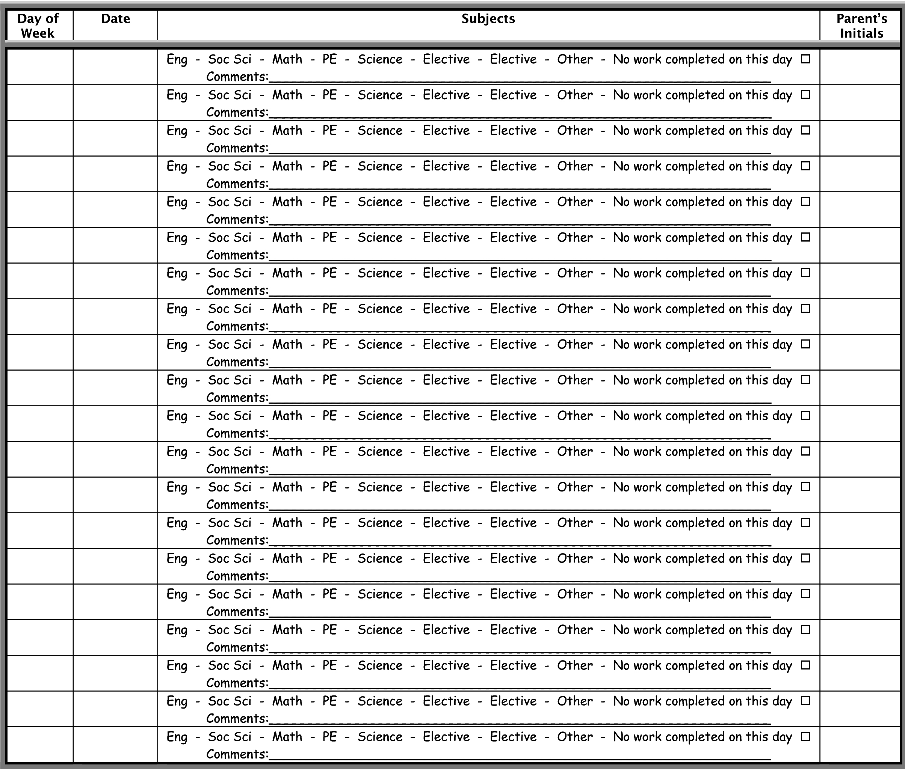

Parent’s signature __________________________________________________________________

Directions: Please complete this form daily. Circle any and all subjects the student worked on during that day and initial in box provided. Please use comment line for any notes if desired. If no schoolwork was completed, please check the appropriate box.

NOTE: Please do not include any holidays or weekends on this record sheet. Only schoolwork completed on official school days, shown on the school calendar on the back of this page, will count toward student attendance.

